

USER MANUAL

PREPARED BY :

Ilyas Bin Mohamad Ali (2018638978)

Khairul Ikhwan Bin Azham (2018424578)

Muhammad Hafiz Bin Harun (2018440724)

ALIFF BIN AHMAD (2016299504)

Table of Contents

INTRODUCTION 3

OVERVIEW 4

HOMEPAGE/LOGIN 4

ADD USER 5

Add User Form 6

Reservation page 7

Edit User 7

Vehicle page 1

Add Reservation Page 1

# INTRODUCTION

The User Manual contains all essential information for the user to make full use of the car rental system. This manual includes a description of the system functions, how to use the system, what are the function of the buttons and more. This also give a step-by-step procedures for system access and use.

# OVERVIEW

## HOMEPAGE/LOGIN

This is the homepage of the website when the users open the website. Users must login or register to link to the next page. The login has two types, user and admin login

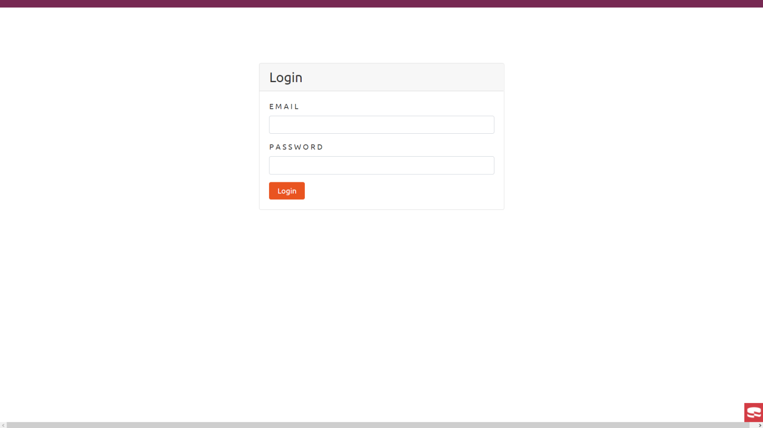

Login Button

## ADD USER

For admin to add user, they can go at register new user.

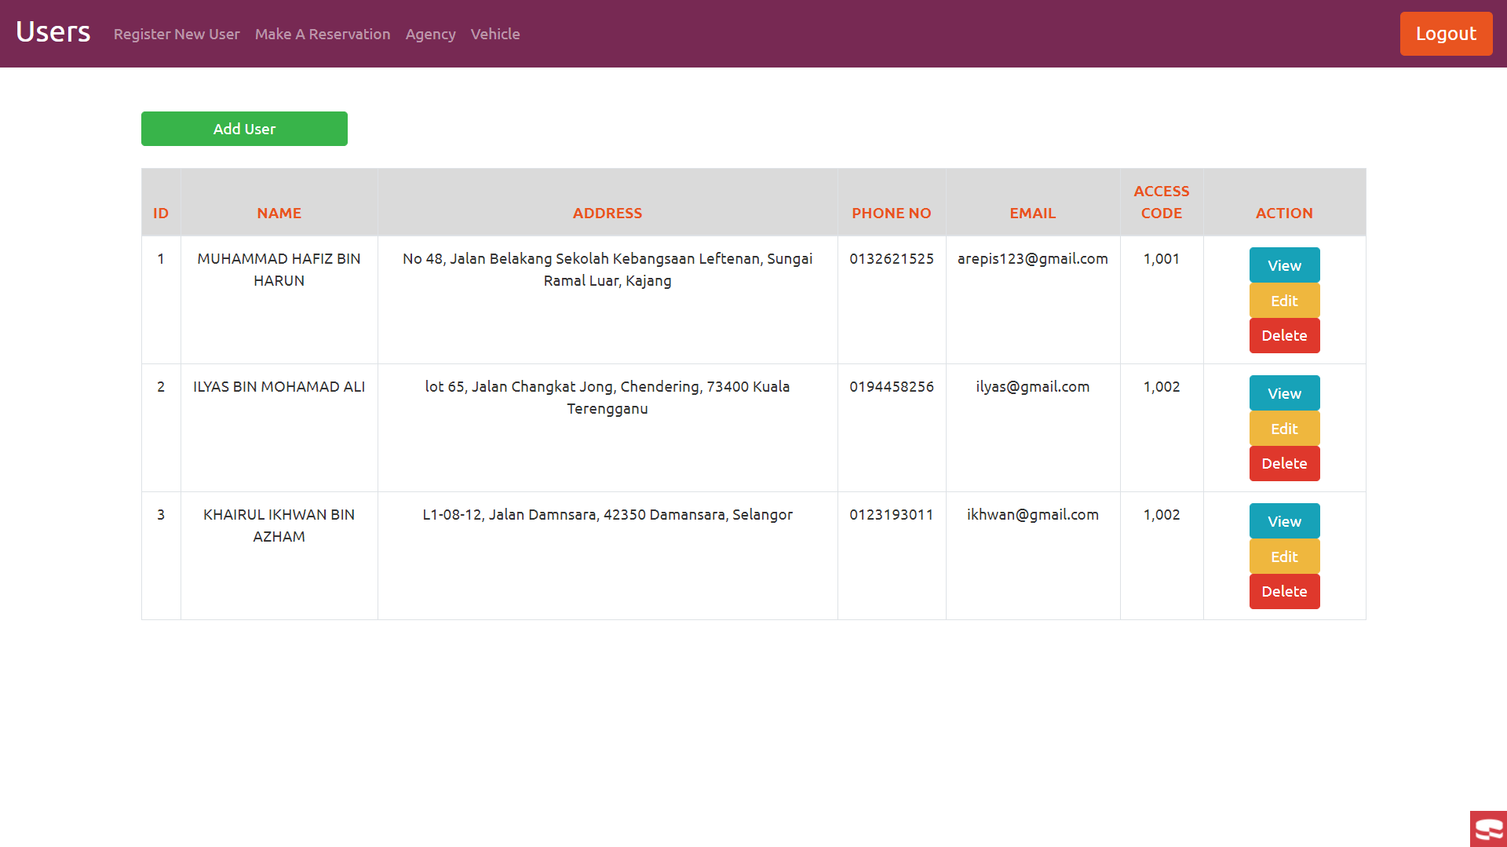

Click this to view selected user

Click this to edit selected user

Click this to add user

Click this to delete selected user

## Add User Form

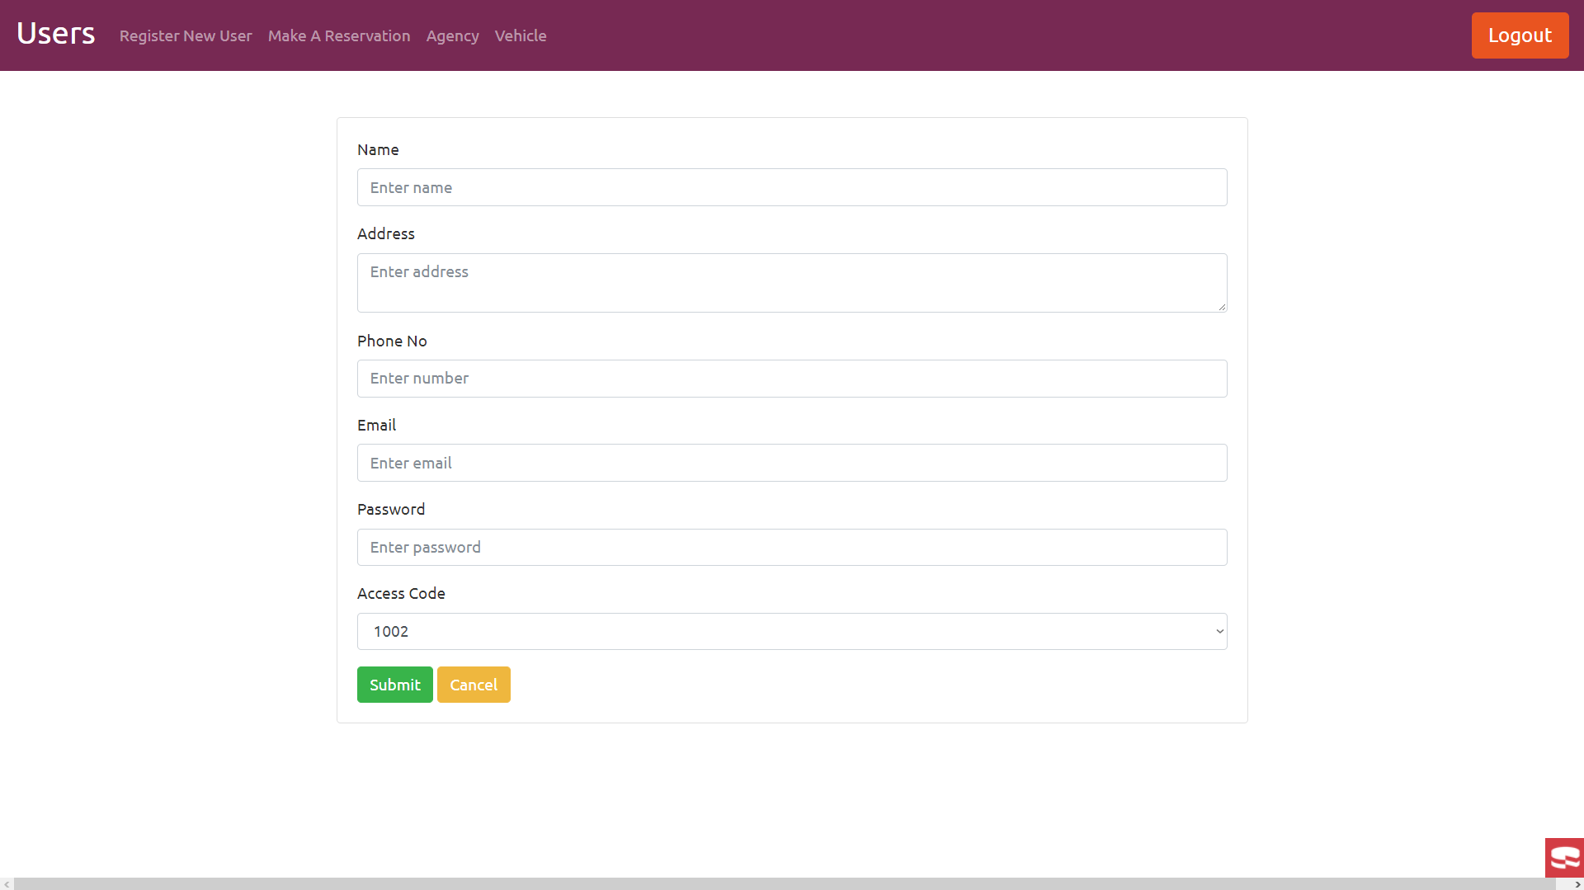

Form to be filled

Submit button

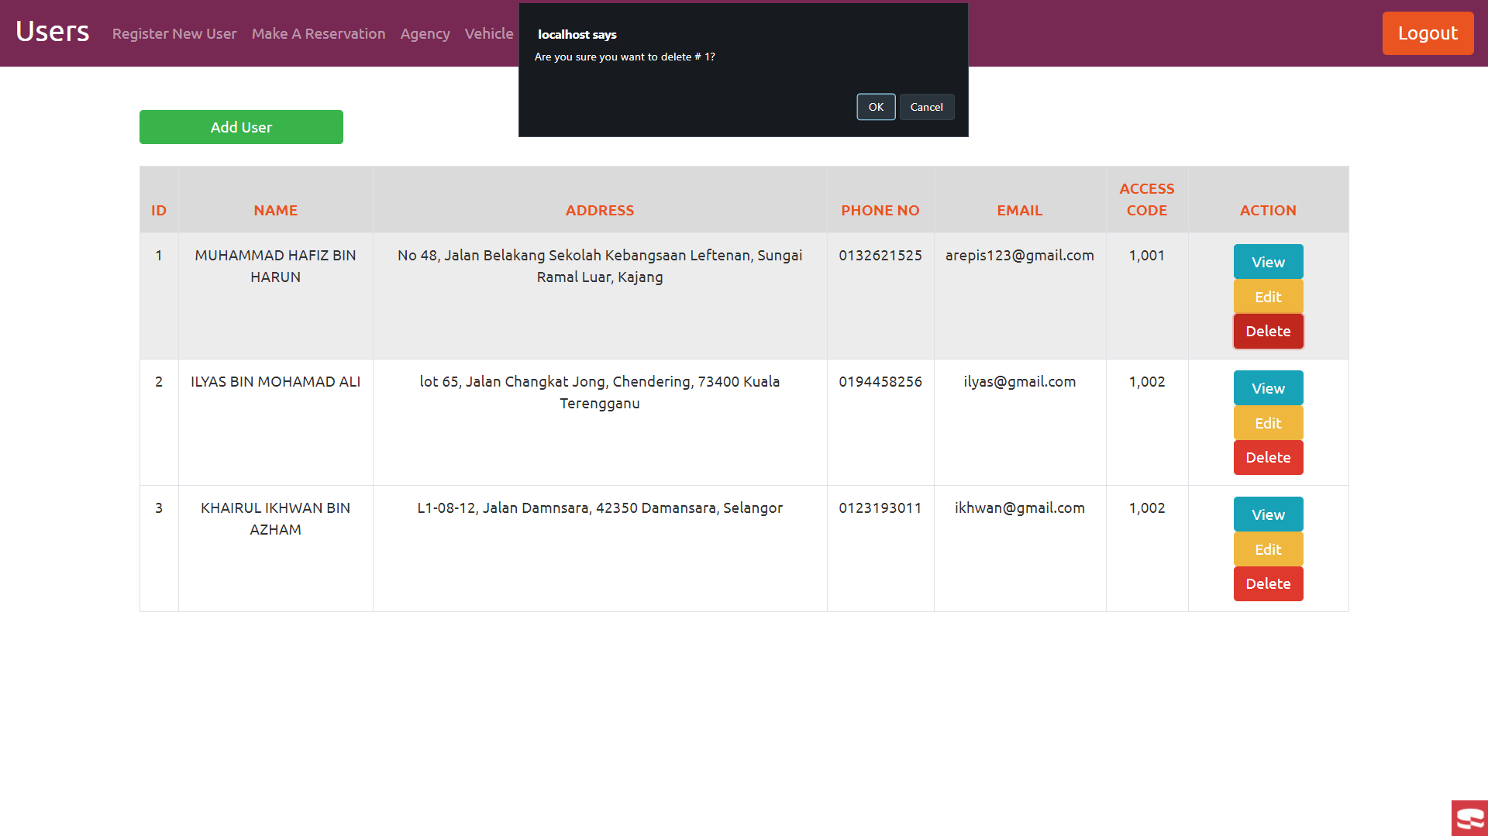When we want to delete, there will pop a message

## Reservation page

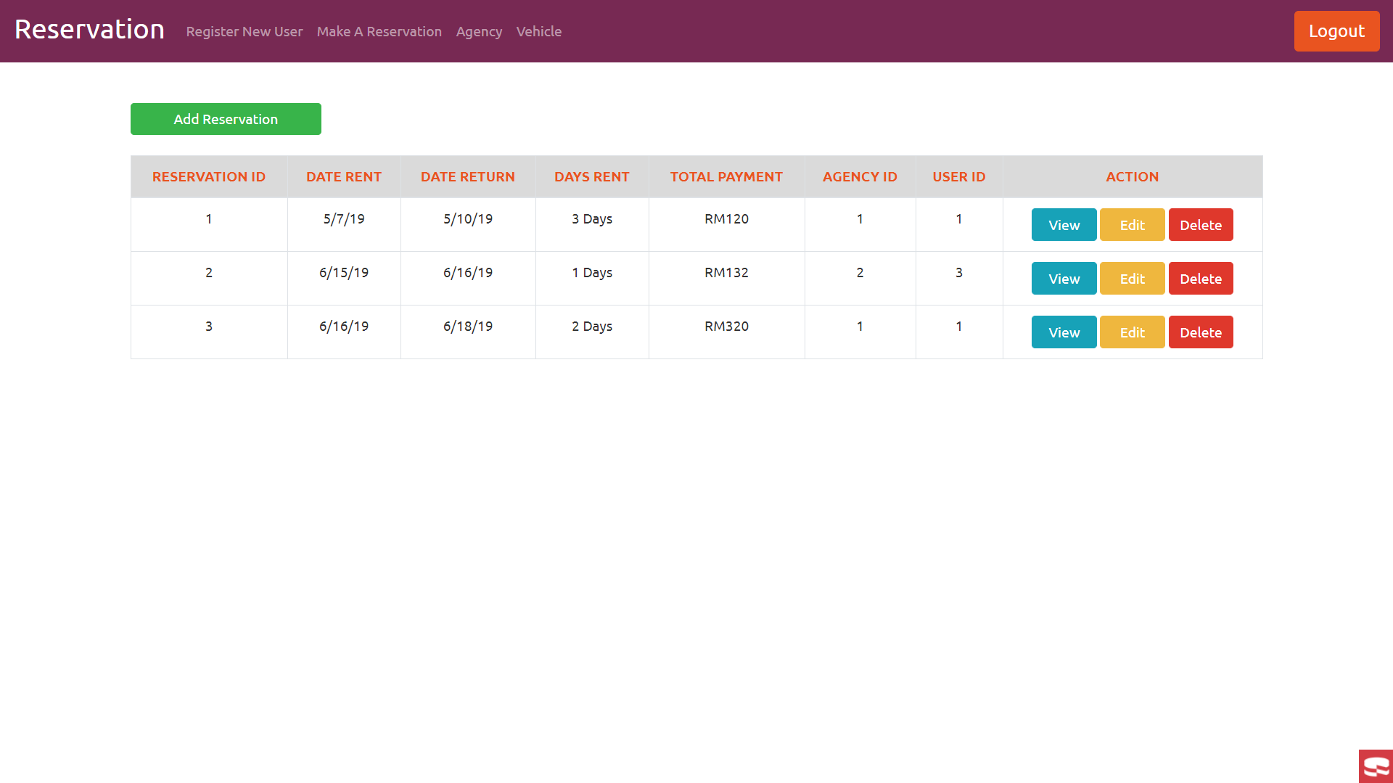The agency also can be edit in the reservation page

To view, edit or delete the current reservation

To add reservation

## Edit User

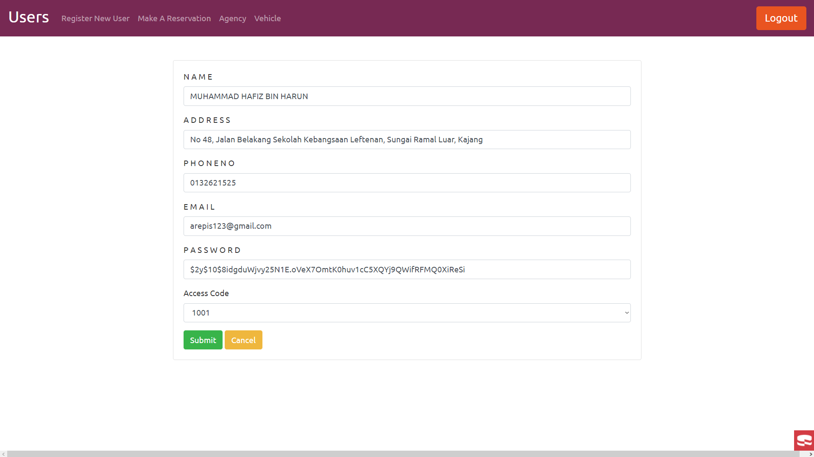

To update the edited field

## Vehicle page

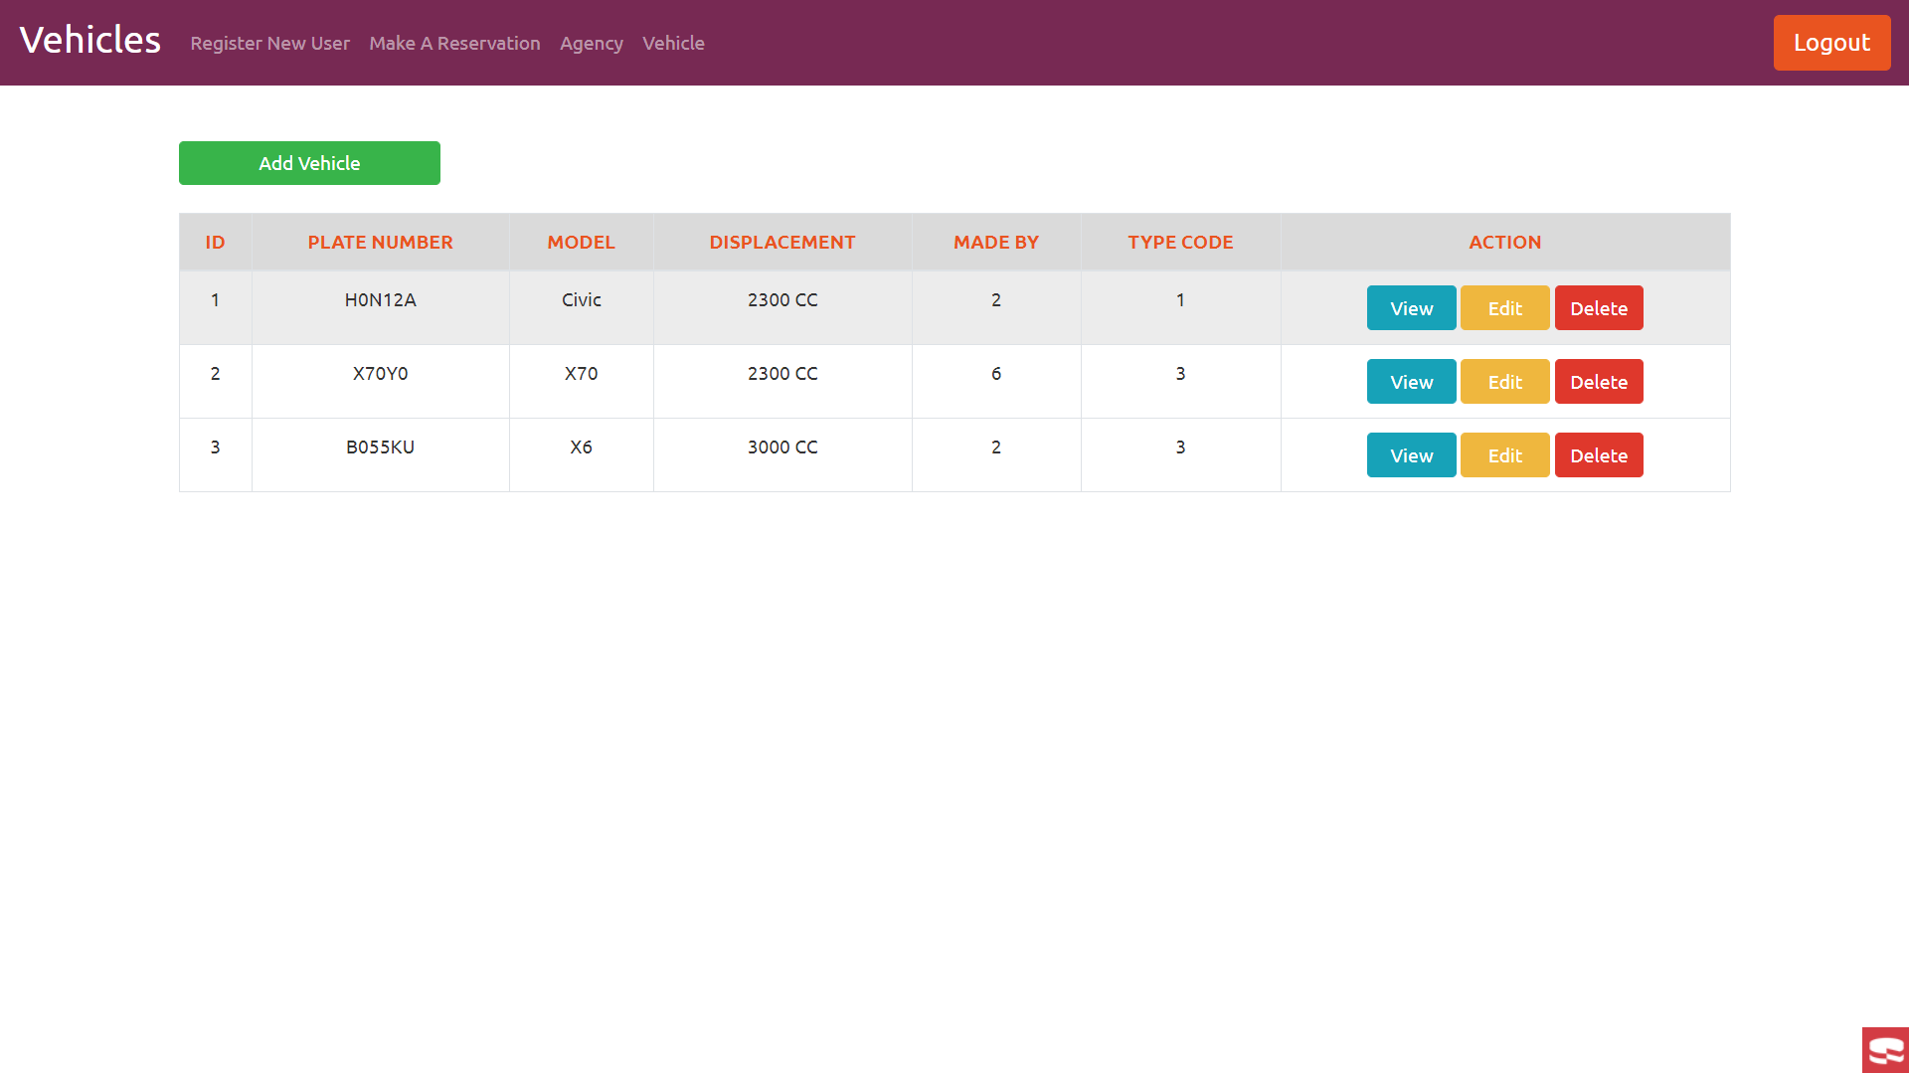

To add vehicle

To view, edit or delete the current vehicle

As for user that not admin, the function is similar, but they cannot register new user.

## Add Reservation Page

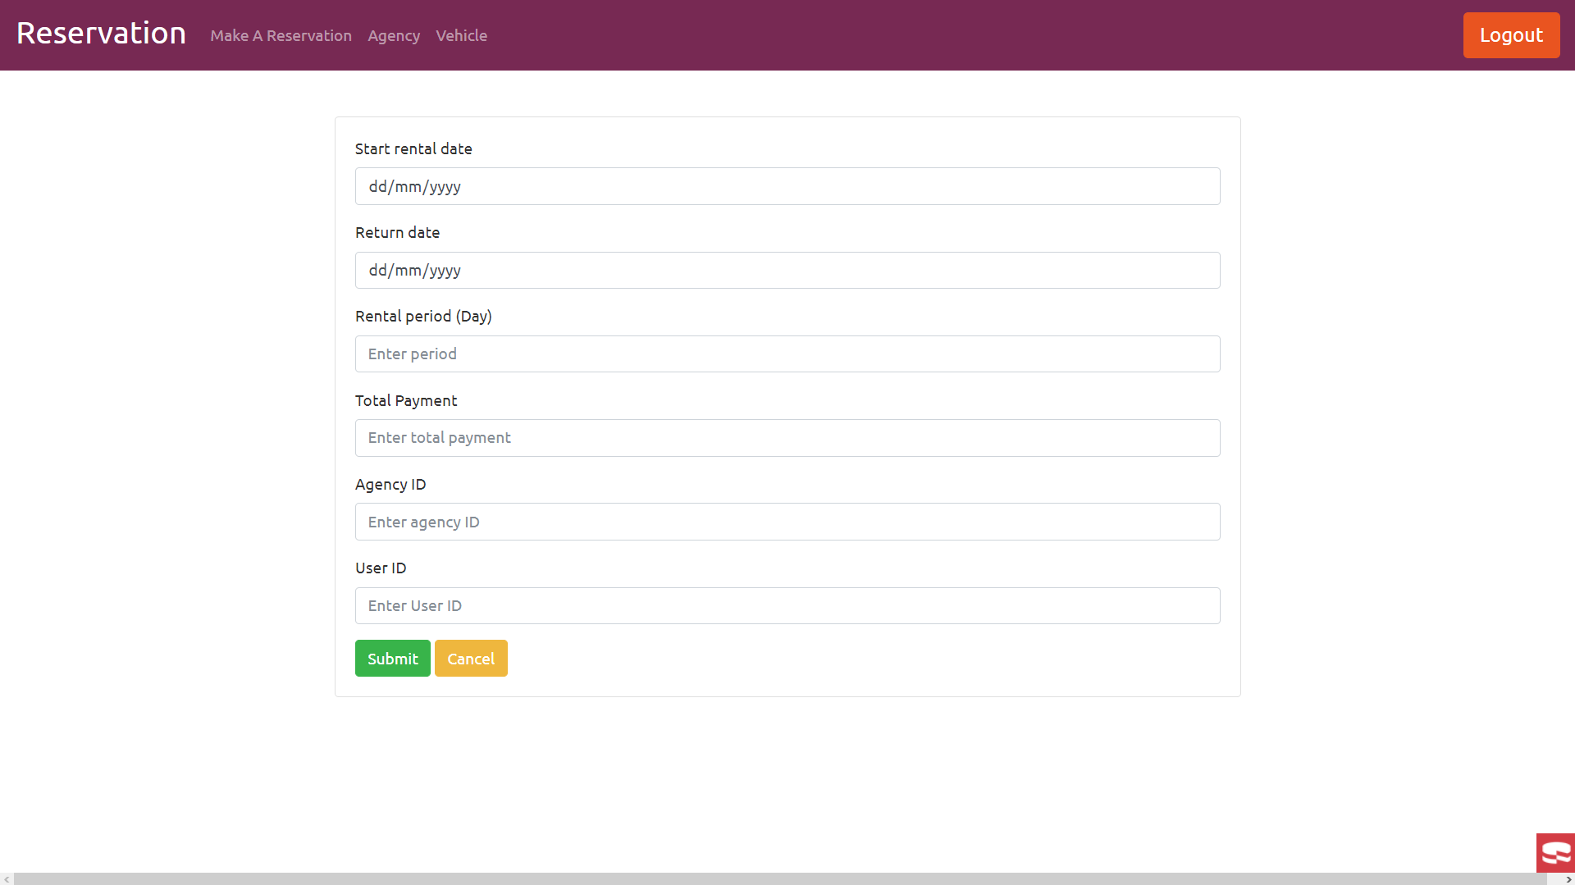

submit and cancel button

Form to be filled